Topic 4: Hedge Funds

Chapter 10: Introduction to Hedge Funds

1. Describe the major characteristics of hedge funds and contrast them with mutual
funds

- Hedge funds are private investment vehicles for qualified investors.
- Portfolios are more concentrated
- Use of derivatives
- Hedge funds may take long or short positions in securities
- Use of leverage
- Use of non-public securities

Vs.

- Mutual funds are regulated and registered with the SEC.
- Non-investable indices may be more representative of the total hedge fund universe, but a new hedge fund investor may not have access to higher earning funds that are closed to new investors.
- Empirical research by William Fung and David Hsieh has shown that mutual fund returns are primarily derived from asset class risk premiums, while hedge fund returns are primarily derived from trading strategy risk premiums.

 William Fung 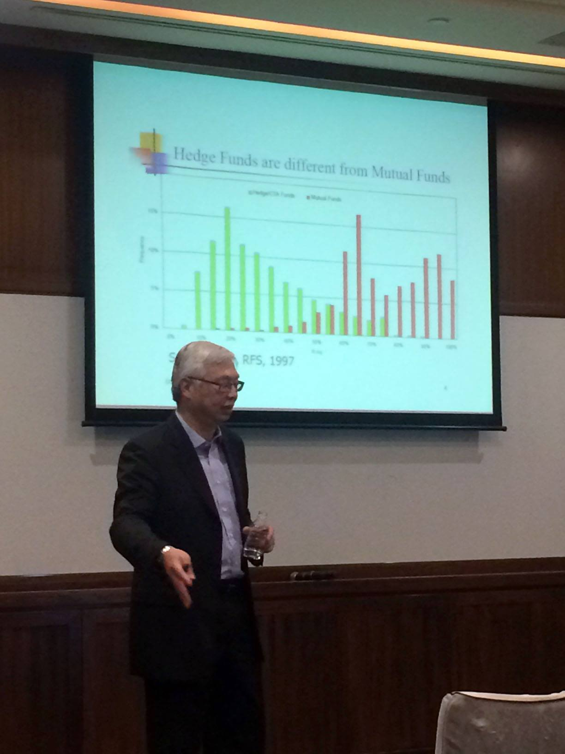 Professor Hsieh

2. Determine whether a particular hedge fund strategy is best categorized as a
market directional, corporate restructuring, convergence trading, or opportunistic
hedge fund.

- Market directional
- Equity Long/Short
- Equity Market Timing
- Short Selling Funds
- Corporate restructuring (event risk the greatest)
- Distressed,
- Merger Arbitrage,
- Event Driven
- Convergence trading (also, event driven)
- Fixed Income Arbitrage,
- Convertible Bond Arbitrage,
- Equity Market Neutral,
- Statistical Arbitrage,
- Relative Value Arbitrage
- Opportunistic
- Global macro
- Funds of Hedge Funds

3. For equity long/short strategies:

a. define the strategy.

- Being both long and short equities
- Net exposure to market risk means that equity long/short managers maintain a beta less than one but greater than zero.

b. identify the portfolio risk and return effects from the ability to go both long
and short.

- Have returns in either direction
- Probably have to take into account – the short position.

c. define fundamental equity long/short strategies.

- Mangers focus on bottom-up analysis. Which involves conducting research at the company level.

d. define quantitative equity long/short strategies.

- Short and long

4. For short selling strategies:

a. define the strategy.

- Go short equities

b. compare the exposures of short selling with traditional long-only managers.

- Short selling risk could be important to the hedge fund industry for two reasons. First, by betting against overpricing, fund managers often hold concentrated short positions and thus their short selling risk is unlikely to be diversified away.

- Second, Shleifer and Vishny (1997) predict that arbitraging—in this case, short selling—is particularly risky for the portfolio management industry due to an agency problem.

- The agency problem is a conflict of interest inherent in any relationship where one party is expected to act in another's best interests. In corporate finance, the agency problem usually refers to a conflict of interest between a company's management and the company's stockholders.

c. compare the styles of short selling with equity long/short managers.

- Means the beta is going to be negative. They hold on to a net short position. Short selling managers also tend to rely on some degree of market timing.
- When market is rising, short seller will rescue the short exposure by investing a portion of assets in cash or T-bills.

5. For activist investing:

a. define the strategy.

- Trying to pick the HOT stock

b. define the source of return.

- Alpha is the source of return

c. describe the available evidence regarding its performance.

- www.theactivistinvestor.com

6. Distressed securities strategies:

- define the strategy.

- Distressed securities funds invest in the securities of companies that are going through a bankruptcy or are likely to declare bankruptcy.

b. define capital structure arbitrage.

- Involves taking long and short positions in a distressed company’s securities based on each security’s order within the hierarchy of asset claims in the event of a bankruptcy liquidation.

- Senior secured debt
- Junior subordinated debt
- Preferred stock
- Common stock

c. describe a particular distressed securities strategy that is most likely to overlap
with private equity firms’ activities.

- May actually get involved with the bankruptcy process to try to find undervalued securities.

7. Merger arbitrage strategies:

- define the strategy.

- Buying the company that is going to be bought out
- Purchasing the stock of a firm that is the target of a takeover and selling the stock of the acquiring firm in an attempt to capture the difference between the post-merger and the pre-merger prices of the companies.

b. identify the main sources of return.

- Stock trades at a discount thinking the merger will not happen.

8. For event-driven strategies:

a. define the strategy.

- Event based strategies can be based on mergers & acquisitions, earning announcements, bankruptcies, stock repurchase plans, special dividend, or other capital market events

b. identify the main sources of return.

- The event does not occur as expected or within the expected time frame, the strategy is likely to fail.
- contrast with merger arbitrage and distressed securities strategies.

9. For regulation D hedge funds:

- define the strategy.

- Regulation D (or Reg D) contains the rules providing exemptions from the registration requirements, allowing some companies to offer and sell their securities without having to register the securities with the SEC.

- Regulation D offering is intended to make access to the capital markets possible for small companies that could not otherwise bear the costs of a normal SEC registration.

- identify the source of return.

- Instead of raising capital in the public market, a company can tap into the private capital markets through an unregistered offering pursuant to Regulation D of the Securities Act.

- What this means is that under Regulation D, issuers do not have register their securities offering with the SEC and only have to file a Form D with the SEC after they first sell securities.

10. For fixed income arbitrage strategies:

a. define the strategy.

- Spread. Buy one fixed income security and sell another fixed income security.

b. describe the investment universe.

- US Treasury, on-the-run and off-the-run
- Corporate bonds
- Municipal bonds
- Sovereign debt
- Mortgage-backed bonds
- Fixed income futures, options or swaps

c. Identify the main sources of return.

- Spread trades.
- Yield curve trades

d. define mortgage-backed security arbitrage strategies (MBS).

- attempt to capitalize on pricing discrepancies in the mortgage-backed security market by buying a MBS and hedging the associated interest rate risk.

e. identify the main risk exposures of mortgage-backed security (MBS) arbitrage
strategies

- Duration. Duration estimates the price impact on fixed-income securities resulting from changes in interest rates. Since MBS cash flows are uncertain, it is virtually impossible to perfectly hedge interest rate risk for MBS
- Convexity
- Yield curve rotation
- Prepayment risk
- Credit risk
- Liquidity risk

11. Convertible bond arbitrage strategies:

a. define the strategy.

- Involves the purchase of a company’s convertible bonds with the simultaneous short sale of the company’s common stock.
- By short selling the stock, the hedge fund manager seeks to eliminate the equity exposure present in the convertible bond.
- The manager receives any interest paid by the bond in excess of dividends paid to the lender of the shorted common stock.

b. identify the sources of return.

- Coupon payments made by the convertible bond
- Interest on the cash proceeds from the short sale of stock, also known as the short rebate.
- Difference between appreciation/ depreciation in the price of the bond and appreciation/ depreciation in the value of the short stock position.

c. identify the role of the delta/hedge ratio.

- Arbitrageur used the delta to determine the appropriate amount of stock to short sell in order to completely hedge the equity exposure present in the bond.

d. identify the components of total return to the strategy.

- It is helpful to think of convertible bonds as consisting of two components: a traditional ("straight") bond that pays a regular coupon and an equity call option on the underlying stock.
- Typically, when a company issues a convertible bond, the conversion price - the effective price at which the bond is converted into the underlying shares - is at a premium (say, 15% or 25%) to the company's stock price

e. for convertible bond arbitrage strategies - identify the main risk exposure.

- Liquidity risk
- Interest rate risk
- Model risk
- Credit risk
- Call risk
- Event risk
- Leverage

f. Calculate the number of shares required in a hedge.

- (Number of shares to short) = (number of convertible bonds) x (conversion ratio) x (hedge ratio)

12. For market neutral strategies:

a. Define the strategy.

- Match long and short position in related securities to eliminate market risk. By neutralizing market exposure, individual security selection becomes the only determinant of return.

b. Define the rule of “one alpha.”

- Rule of one alpha says there is only one source of risk-adjusted return.
- In the case of the market neutral hedge fund manager, the one alpha refers to security selection.
- Long and short positions are integrated to neutralize “beta” risk exposure to the market and any particular sector or industry so that the selection of individual securities, or alpha, is the sole driver of returns.

c. Define the term “dollar neutral.”

- Dollar neutral refers to holding equal amounts of long and short positions, so the manager has zero net exposure to the market

d. Define the role of factor models.

- Factor models are complex regression equation that relates security returns to one or more specific factors. Market neutral managers use these models to identify the financial variable that have the greatest impact on stock prices.

- Once the manager identifies the most influential factors, stocks are chooses based on those factors.

- Factor models are often called alpha engines because they drive the security selection process, which is the sole source of return for a market neutral portfolio.

- Factor models are complex regression equations that use factors to explain security returns. In a market neutral strategy, they are called alpha engines because they drive the security selection process, which is the sole source of return for a market neutral portfolio.
The alpha of an active manager should be computed by regressing excess returns earned by the manager against the excess returns of investable factors (i.e., benchmarks) using an excess return factor model.
The conditions required to compute an active manager’s alpha are:
- The returns used in the regression should be excess returns (i.e., returns in excess of a risk-free rate, such as U.S. Treasuries).
- The factor returns should be returns available to investors with low to zero cost (i.e., the indices or benchmarks should be investable).

13. For Relative-Value arbitrage strategies

a. Define the strategy.

- PAIRS. To take advantage of relative pricing between two securities. Includes stocks, bonds, options, or futures contracts.

b. For relative value arbitrage strategies, identify the market neutral nature of the strategy.

- By taking a long position in one security and a short position in a related security, the systematic risk inherent in each security individually is canceled out, effectively neutralizing market exposure.

- The risk exposure is security specific risk If the manager has correctly identified when on security is over or underpriced relative to a second security and structure long/short trades accordingly, the manager can realize significant returns that are uncorrelated. With market movements.

c. Define stub trading strategies.

- Stock-based strategies that involve the piece of an equity security that is left over from a merger or recapitalization.

d. Define volatility arbitrage strategies.

- Attempt to capitalize on differences in the implied volatility that exists between options prices on a particular stock.

14. For global macro strategies:

a. define the strategy.

- Use a top-down approach to analyzing global macroeconomic events and identifu investment opportunities across global financial markets.
- Use a top down approach to analyzing global macroeconomic events and identify investment opportunities across global financial markets.
- Macro hedge fund manager will invest anywhere in the world based on forecasots of economic growth, currency movements, and change in interest rates.

b. for global macro strategies, describe the investment universe.

- Have the most extensive investment universe of nay manager in that they can invest in any type of security, in any market around the world.

c. explain why global macro funds have fallen out of favor.

- Many institutional investors moving into the hedge fund marketplace have demanded a more well defined and focused strategy from these managers

15. For funds-of-funds:

a. define the role of funds of funds managers.

- Invest in a portfolio of other hedge funds. The managers take a tactical approach by allocating to various hedge fund strategies or managers that the fund of funds manager believes have the best opportunity for return in the correct market environment.

b. identify the main advantages and disadvantages associated with funds of funds
as compared to direct investment in hedge funds.

- Primary advantage is diversification

16. For multi-strategy hedge funds:

a. describe the advantages and disadvantages of multi-strategy hedge funds.

Multi-strategy funds are designed to take less market exposure, with long and short positions often sized equally. This makes them more likely to perform better when funds that take more risk stumble in volatile markets.

b. compare multi-strategy hedge funds-to-funds-of hedge funds.

Chapter 11: Establishing a Hedge Investment Program

- Explain why hedge funds should be part of a diversified portfolio.

- The historical data shows that, compared to a broad stock market portfolio, hedge funds have had lower volatility and provide a good opportunity for diversification while increasing return.

- For historical performance of hedge funds:

- The average hedge fund lost 18 percent of its value in 2008, the industry's worst performance on record and down from an average gain of 9.96 percent in 2007.

a. Contrast the historical absolute performance of hedge funds with the
performance of the S&P 500.

- Studies found that most hedge fund categories had lower volatility, as measure by standard deviation, than the S&P 500
- Lower Volatility

c. Discuss the academic evidence on the contribution of hedge fund allocations to
the performance of a broad stock market-based portfolio.

- Adding hedge funds to a broad stock market-based portfolio was found to increase returns and reduce risk.
- Studies found that the addition of hedge funds to traditional stock and bond portfolios consistently ked to higher Sharpe ratios.

d. Discuss the academic evidence on the diversification benefits of hedge fund
allocations.

- The primary driver of correlation, which measure the relationship between two variables.
- Studies conclude that most hedge funds have a low correlation with traditional asset classes.
- Hedge funds offer consistent positive absolute performance with less volatility than stocks and strong diversification potential due to their low correlation with traditional financial assets.

e. Identify the main drawbacks of the academic evidence on hedge fund
performance.

- Time period studied
- Similar exposure
- Studies are subject to database biases

3. Discuss the academic evidence on hedge fund return persistence.

- Return persistence
- Volatility persistence
- Serial correlation

4. Discuss the academic evidence regarding the impact of hedge funds on the
financial markets.

- Academic studies do not support the notion that hedge funds cause financial disasters; despite the blame such disasters receive.
- A study by Fung and Hsieh in 2001 found that significant financial market events such as the Oct 1987 stock market crash were caused by fundamental factors, not hedge funds.

5. Identify potential goals of a hedge fund investment program.

- Return enhancement
- Risk Reduction

6. Identify the opportunistic investment potential of hedge funds.

- Adding value to an existing portfolio through the specialization
- Filling gaps in the investment spectrum of an existing portfolio

7. Identify the goals of an opportunistic hedge fund investment program.

- Adding value to an existing portfolio through specialization
- Filling gaps in the investment spectrum of an existing portfolio

8. Identify the purpose of a hedge fund-of-funds program.

- Academic evidence shows that the marginal diversification benefits received from combining hedge funds into a hedge fund of funds begins to decline with five individual hedge funds.

9. Discuss the academic evidence on hedge fund-of-funds programs.

- Academic evidence shows that the marginal diversification benefits received from combining hedge funds into a hedge fund of funds begins to decline with five individual hedge funds.
- A fund of funds portfolio of five hedge funds can eliminate 80% of the individual manger’s idiosyncratic risk
- A portfolio of 20 hedge funds can eliminate 95% of the individual manager’s idiosyncratic risk

10. Define risk budgeting.

- This is the process of defining an acceptable amount of risk and then allocation that risk across a portfolio.
- The risk budgeting process allows an investor to identify the contribution of various sources to portfolio risk. Then, throughout the portfolio, the investor sets target risk levels, which are called risk budgets.

11. Identify the risk budgeting potential of hedge fund investments.

- Low standard deviation
- Low correlation with traditional asset classes

12. Calculate hedge fund allocations based on risk budgeting constraints.

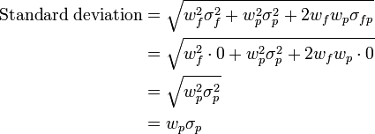

13. Calculate the hurdle rate for a hedge fund of funds investment as an addition to a
diversified portfolio.


- Hurdle rate is the rate that must be surpassed for returns
- Given the information below, calculate the hurdle rate for a hedge fund of funds investment as an addition to an S&P 500-based portfolio. The S&P 500 return is 12%, the risk-free rate is 4%, the correlation of the hedge fund with the market is 0.5, the standard deviation of the market is 20%, and the standard deviation of the hedge fund is 30%.

R_{H} = (12% – 4%) × 0.5 × (30%/20%) + 4% = 10% : It’s like CAPM
(hedge fund / standard deviation of the market)

14. Understand the portable alpha strategy.

- Jump to other investments after you get a return

15. Calculate alpha of a hedge fund and explain how it can be ported to another

- Total return of the portable strategy

16. Discuss the academic evidence regarding hedge fund investments as substitutes
for investment grade bonds.

- The volatility of hedge funds is marginally higher than the volatility of investment grade bonds, but with a significantly higher return.
- Hedge funds can be considered a bond substitute in an efficient portolio
- Hedge funds VS. Bonds
- The volatility of hedge funds is marginally higher than the volatility of investment grade bonds, but with a significantly higher return.

17. Identify the “absolute return” nature of hedge fund products.

Note: Direction does not matter
- Absolute return hedge fund strategies attempt to earn consistent, positive returns regardless of the direction of the market.
- Hedge fund managers claim that they have the ability to achieve absolute returns because they follow a skill based investment process, meaning that returns depend on the manager’s skill at selecting specific securities rather than the performance of a broader asset class.

Chapter 12: Due Diligence for Hedge Fund Managers

1. Describe the phases of due diligence.

- Hedge fund structure review
- Investment strategy review
- Performance review
- Risk assessment
- Administrative review
- Legal review
- Checking references

2. Identify three fundamental questions for understanding the nature of a hedge fund
manager’s investment program.

- What is the hedge fund’s investment objective?
- What is the hedge fund manager’s investment process?
- What is the hedge fund manager’s competitive advantage?

3. Identify three essential questions for understanding a hedge fund manager’s
investment objective.

- In which markets does the hedge fund manager invest?
- What is the hedge fund manager’s general investment strategy?
- What is the hedge fund manager’s benchmark, if any?

4. Discuss the “black box” investment process.

- For black box managers, the box itself is the investment process.

5. Define process risk.

- Unquantifiable, idiosyncratic, manager-specific risk that arises from the operations of a firm.

- Process risk is also referred to as uncompensated risk because it is not part of the fundamental economic risk that is inherent in an investor’s asset allocation.

- Sort of like ‘goodwill?’

6. Identify two distinct information processing skills.
- Filtering information
- Gathering information

7. Understand the structural review phase of due diligence.

- How the business is actually set up. Review of the registrations the fund may have with regulatory bodies. Review of key personnel.

8. Define MASTER TRUST.

- A master trust structure is used to invest a hedge fund’s assets in a way that accommodates the various tax domiciles of the fund’s domestic AND foreign investors.

9. Identify tax consequences of a MASTER TRUST structure to investors.

- The master trust itself is tax neutral, meaning there are no direct tax consequences at the master trust level.
- A master trust is usually set up in a place that does not have corporate income taxes, such as Bermuda or the Cayman Islands. This means that the master trust does not pay corporate taxes, which allows any tax consequences associated with the hedge fund to flow down to the tax code of watch investor’s home country.

10. Identify relevant questions about the hedge fund manager’s organization.

- Where is the hedge fund manager located?
- What is the organization structure of key personnel?
- Wheat is the educational background and prior experience of the principals of the firm?
- How did you learn to short stocks?

11. Identify the role of the CFO of a hedge fund in the relationship between a hedge
fund manager and an investor.

- Is responsible for reporting the fund manager’s performance results to investors. As a result, the CFO should have a strong accounting background.

12. Identify the role of hedge fund ownership in due diligence analysis.

- Knowing who owns the fund is also a way to determine whether interests are aligned between the fund manager and its employees.

13. Identify the various regulatory registrations required of a hedge fund manager
(U.S.).

- Investment Adviser Registration with SEC
- NFA
- CFTC

14. Identify relevant outside service providers to hedge fund managers.

- Outside Auditors
- Prime Brokers
- Legal Counsel

15. Identify the role of prime brokers in the hedge fund business.

- Prime brokers are responsible for executing trades, lending securities to sell short, and providing the means for the hedge fund to leverage its positions
- The prime broker is in the best position to know exactly what positions the hedge fund holds at a given point in time.
- Prime Broker can demand a margin call

16. Discuss documentation of hedge fund investment styles, hedge fund investment
markets, and hedge fund investment securities.

- Documentation of Style
- Documentation of the investment markets
- Documentation of investment securities

17. Define the short volatility strategy.

- Selling OTM calls or puts against a portfolio

18. Identify the role of passive benchmarks in evaluating hedge fund manager performance.

- Benchmarking isn’t the greatest – but, using a narrow benchmark that focuses on a particular segment or sector of the market may be the best compromise.

19. Identify the role of hurdle rates in evaluating hedge fund manager performance.

- A return the manager should exceed over a certain time period.

20. Identify the role of current portfolio position snapshots in the due diligence
process.

- Let’s a potential investor see exactly what positions a manager is correctly holding in the hedge fund portfolio.
- Long vs. short exposure
- How much cash the investment manager is keeping h tund
- How many different security the manager holds
- How the portfolio is positioned relative to current market conditions

21. Discuss the hedge fund investment idea generation process.

- How the manager develops ideas and when these ideas work (during bull markets or bearish markets.)

22. Discuss capacity in hedge fund investments.

- Have fund investors frequently have limited capacity because they are targeting a specific investment group.

23. Identify three relevant performance review questions.

- What risks are managed by the fund manager
- How does the fund manager measure risk?
- How is risk managed?

24. Define drawdown.

- A drawdown is the maximum percentage loss from a hedge fund. This is calculated by subtracting the lowest value from its peak net asset value.

25. Contrast drawdown in long-only investments with drawdown in hedge fund
investments.

- Both hedge funds and mutual funds have drawdowns – but, the mutual fund – as a long only endeavor, for mutual funds the drawdowns are often motivated by downward courses of the market indices.

26. Identify the role of withdrawals in due diligence analysis.

- Withdrawals can be painful – especially when you have to sell out illiquid instruments to fund for the withdrawal.

27. Identify three relevant questions for the risk review phase of due diligence
analysis.

Long, persistent, same

- How long has the fund manager been actively managing a hedge fund?
- Have performance results for the fund shown persistency over time?
- Are the performance results the same or different for each hedge fund the manager manages?

28. Define active risk, short volatility risk, and counterparty risk.

- Active risk - is also known as Tracking Error
- Short volatility risk – fund can be exposed to unlimited losses
- Counterparty risk – risk that the other party will default on the contract

29. Identify the role of leverage limits in hedge fund risk management.

- The investor should document both the highest amount of leverage ever used for a fund as well as the average amount of leverage used under typical conditions

30. Discuss the review of civil, criminal and regulatory actions in due diligence
analysis.

- Administrative review phase of the due diligence process

31. Identify potential effects of high employee turnover on hedge fund performance.

- It affects productivity. Employee productivity and general firm performance can be negatively

32. Define the role of an account representative.

- Handle issues regarding performance withdrawals,
- increase investment,
- Distributions and meetings.

33. Identify the role of disaster planning in the hedge fund business.

- Commonplace after 9/11. Must have a recovery plan in place.

34. Identify the main implications of the limited partnership structure of a hedge fund
investment.

- Number of units that the investor owns entitles het to a pro rata share of the returns earned buy the hedge fund.

- Provides a financial firewall for the investor as well. The maximum downside is known with certainty.

35. Contrast separate accounts with limited partnerships.

- Separate accounts facilitate reporting

36. For hedge fund fees, define:

a. the “2 and 20” fee structure.

- 2 percent management fee and 20 percent incentive fee.

b. high watermarks.

- Hedge fund manager cannot collect an incentive fee until the past performance is surpassed

c. incentive fees.
- A fund manager might receive an incentive fee if a fund performs well over a given period.
- The fee amount can be based on net realized gains, net unrealized gains, or net income generated.
- A 20% incentive fee is typical for hedge funds.
- Critics of these fees suggest that they encourage managers to take outsized risks to boost returns.

d. clawback.

- These are rare in the hedge fund world. More common in the private equity world. Allows investors to take back incentive fees. Generally, occurs when the hedge fund manager fails to produce an agreed upon hurdle rate

37. Define the lock-up period.

- You give the money to hedge fund – and it is locked up.

38. Identify the benefits of a lock-up period to an investor.

- Investors can be assured that their investments will not be undermined by a fickle investor.

39. Define the notice period.

- Limited partners must give notice to the hedge fund manager that they intend to redeem. This can be from 30 to 90 days in advance of the redemption.
- The purpose is to give the hedge fund manager the ability to position the hedge fund’s portfolio to finance the redemption request.

40. Identify the role of high subscription amounts in hedge fund investments.
- A high-water mark is the highest level in value an investment account or fund has reached.
- A high-water mark is often used as a demarcation point in determining performance fees that an investor must pay.
- The purpose is to protect investors from paying a fee for poor performance, and from paying a fee repeatedly every time the fund earns a profit.
- With a high-water mark, the investor pays a fee that only covers the amount the fund earned between the point of entry and its highest level.

41. Identify the role of maximum subscription amounts in hedge fund investments.

- Some funds have maximum subscription amounts setting an upper limit on the amount a single investor can invest in a hedge fund prevents one investor from having too large of a position compared to other investors in the fund.

42. Identify potential sources for due diligence reference checks.

- Primary service providers
- Existing clients

43. Identify relevant due diligence questions to be asked to existing hedge fund
clients.

- Report produced in a timely manner?
- Reports easy to understand.
- Is the hedge fund manager responsive to questions?
- Had the hedge fund manager consistently maintained the fund’s investment process?
- Do you as an existing client have any concerns about the hedge fun’s perfonace?
- Would you invest more money with the fund manager?

Chapter 13: Risk Management Part 1: Hedge Fund Return Distributions

1. Describe the style analysis and asset-based approach to modeling hedge fund
returns.

- Fung and Hsieh attempt to analyze the returns to hedge funds by applying the factor or style analysis conducted by William Sharpe with respect to mutual funds. He determined that up to 90% of mutual fund returns are explained by asset class returns.
- In a more recent paper, Fung and Hsieh propose an asset-based (ABS) factor model consisting of seven risk factors attempting to capture the systematic risk that diversified portfolio of hedge funds are subject to.

Asset-based arises because these risk factors are all based on observable, tradable securities and their derivatives.

- Excess return of the S&P
- Small cap stocks – large cap stocks
- Return on the 10 year
- The return on Baa bonds above the return of the 10-year Treasury bond
- Portfolio of call and put options on bonds
- Portfolio of call and put options on currencies
- Portfolio of call and put options on commodities

Side note:
Understand Moments:
- First moment is Expected Return
- Second moment is Standard Deviation

2. Describe the academic evidence on the suitability and limitations of the use of
market factors.

- These studies indicate that hedge fund return patterns do not map as well onto financial assets as do mutual fund returns.

3. Describe the major risks affecting:

SEE EXHIBIT
a. market directional funds.
b. corporate restructuring funds.
c. convergence trading funds.
d. opportunistic funds.

- Question from exam: Anson places the “Activist Investors” strategy within which hedge fund category? Answer: Market Directional
- Corporate Restructuring is subject to Event Risk

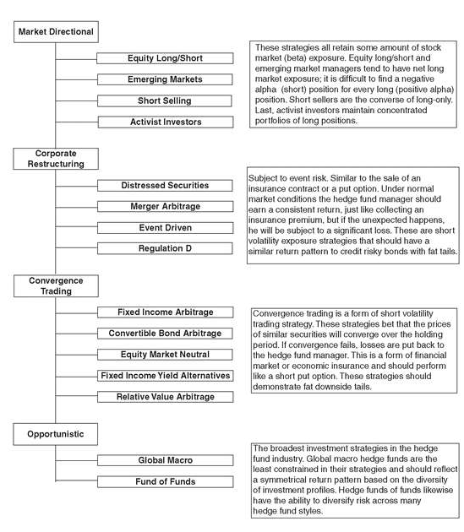

4. Compare and contrast the skewness and kurtosis of return distributions for
convergence trading and corporate restructuring funds with:

- hedge funds having more market exposure.

- The descriptive statistics show that, in particular, the hedge fund strategies of Fixed Income Arbitrage and Event-driven Opportunities, despite displaying low volatility, exhibit latent higher moment risk in the form of negative skewness and high kurtosis.

b. hedge funds that minimize credit risk and market risk.

- These funds exhibit return distributions that, like credit risky securities, are negatively skewed with fat tails
- It’s like selling insurance
- Collect premium if it works – but, if event happens then downside exposure.

5. Explain the similarities and differences among the return distributions of equity
long/short funds, short selling funds, emerging markets funds, and activist funds.

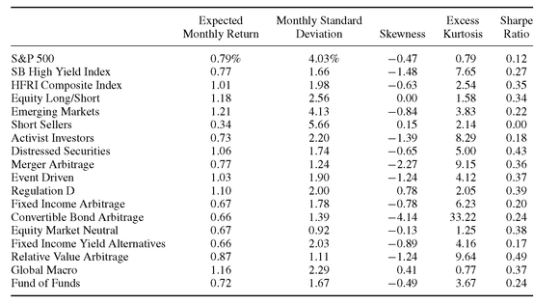

Funds that are exposed to stock market risk: equity long/short, emerging market, and short sellers.

- Equity long/short funds: They tend to have a long bias – because manager tends to stay long. There is a lack of skewness because it is more symmetrical.
- Short selling funds: Do well in down markets. We might expect a slight positive skew to their return distribution. Because they time covering their shorts in an up market.
- Emerging market funds: Generally, follow the same long/short investing as equity long/short hedge funds. However, they often follow a broader market than domestic equity long/short for two reasons 1) In developed countries, a greater information advantage can be achieved 2) there is greater liquidity in developed markets
- Activist funds: tend to take large, long-only positions in public companies and then challenge the executive management and the board of directors to change their governance structure in an attempt to favor the creation of shareholder wealth.

6. Explain the similarities and differences among the return distributions for
distressed securities funds, merger arbitrage funds, event driven funds, and
Regulation D funds.

- Distressed securities
- Merger arbitrage funds
- Event driver funds
- Regulation D funds

7. Explain the similarities and differences among the return distributions of fixed
income arbitrage funds, convertible bond arbitrage funds, equity market neutral
funds, fixed income yield alternative funds, and relative value arbitrage funds.

- Fixed income arbitrage funds
- Convertible bond arbitrage funds
- Equity market neutral funds
- Fixed income yield alternative funds
- Relative value arbitrage funds

8. Explain the similarities and differences among the return distributions of global
macro funds and funds of funds.

- Global macro funds
- Fund of funds

We find, surprisingly, that there is a negative skew for Fund of Funds.

9. Identify three strategies that have positively skewed returns.

- Equity long/short
- Short selling
- Market timing

All have positively skewed returns and the most market risk exposure

10. Describe the distribution of returns for three strategies that exhibit the most
market risk.

- Equity long/short, emerging markets, short sellers, and activist investors.

11. Identify the similarities between selling insurance, convergence trading, and
corporate restructuring funds.

- Most convergence trading and corporate restructuring funds are exposed to event risk (equity market neutral and statistical arbitrage strategies are the exceptions). The event risk of these funds is similar to that of a company selling insurance.
- Selling insurance has also been compared to writing a PUT option.

12. Explain the risk management implications of the similarities between selling
insurance and convergence trading, and corporate restructuring funds.
The following risk management implications gleaned from the insurance industry can be applied to investing in convergence trading and corporate restructuring funds:
- Diversify. Insurance companies diversify across policyholders to reduce risk. This can be accomplished in hedge fund investing by investing in multiple funds.
- Seek varying industry and market capitalization exposures. In addition to diversifying across funds, seek funds that invest in different industries and/or market capitalizations.
- Limit leverage. Leverage compounds the short volatility risk. Therefore, managers should limit the use of leverage.

13. Identify two strategies that have both low market risk and low insurance risk.

  - Equity Market neutral
  - Global Macro

These have the most conservative risk profiles. In fact, global macro hedge fund managers exhibit a return which is very symmetrical.

14. Define short volatility risk.

- Short vega

15. Explain the purpose of Multi-Moment optimization.

- Multi-moment optimization incorporates skewness and kurtosis into portfolio optimization analysis in order to capture a hedge fund manager’s off balance sheet risk.
- Complex procedure

Chapter 14: Risk Management Part II : More Hedge Fund Risks

1. Define Process Risk.

- Process risk is the inability to examine, understand, or even determine the process used by the hedge fund manager in selecting investments.
- VS Transparency which is the inability to “see” the process
Asymmetry issues can be addressed through governance in the investment management industry in the following ways:
- Products that deliver beta exposure should have minimal cost to reflect the limited skill required to capture beta.
- Alpha and beta should be separated so that the content of alpha and beta in products is transparent. This would allow investors to more accurately assess fees.
- Investment managers know on an ex-ante basis their skill level and whether their investment strategies can expect profits in future economic environments, while investors may not know this information. Therefore, managers should have transparency in their investment management processes.
- Investors must accept that there is a tradeoff between alpha and transparency of investment management processes. As transparency of investment management processes increases, the opportunities to earn alpha decrease. Therefore, complete transparency is not desirable.
- Because of the incentives for managers to accept excessive risk, investors should require a certain level of transparency in risk exposures.

2. Identify ways of managing process risk.

- “Pop the hood”
- Look at the computer algorithms
- You can diversify process risk by diversifying across several hedge funds

3. Define mapping risk.

- No standard platform for measuring risk and no standard format for reporting risk.
- Trying to figure out where the risk comes from.
- Fung and Hseih

4. Identify ways of managing mapping risk.

- Report to a Centralized Prime Broker who would keep names secret

5. Define transparency risk.

- The inability to see what the hedge fund manager is doing.
- Since hedge funds are not regulated by the SEC, they are not required to report their positions. As a result, investors are subject to transparency risk.

6. Explain the effect of lack of transparency on portfolio-level risk aggregation.

- Lack of authenticity of operating results
- Inability to monitor risk and measure performance
- Inability to assess the effects of an allocation to hedge funds on total portfolio risk

7. Define and calculate Value at Risk (VaR).

- Is defined as the maximum loss over a defined period of time at the stated level of significance, given normal market conditions.
- 1) Confidence level, 2) Time Horizon, 3) Time Period over which to measure Volatility
- It is Not Additive
- Also assume that hedge Fund returns are normally distributed - no skew or kurtosis.
- Assumes normal market conditions
- While the confidence level covers both sides of the mean, the VaR measure is only concerned with underperformance so only one calculation needs to be performed.
0.75% − 1.645(4.25%) = –6.24%
Only concerned with negative amount

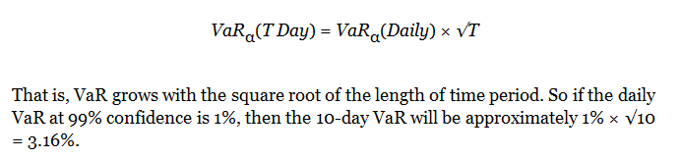

8. Define Risk Management risk.

- Possibility that risk is being measured and managed incorrectly
- Usage of VaR in an incorrect fashion
- Calculations of hedge fund managers must be synchronized
- This can occur when comparing the risk of difference hedge funds.

9. Identify the drawbacks of applying the VaR methodology to hedge fund
investments.

- VaR is not consistent with confidence level, time horizon, and time period
- VaR measures are not additive
- VaR is often based on normal distribution
- VaR is based on normal market conditions

10. Define Data Risk.

  - Time period over which the studies were performed
  - No comprehensive database
  - Hedge fund index data are inherently biased
  - Survivorship bias

Data has three issues

- Survivorship
- Selection
- Backfilling
- Catastrophe or Liquidation Bias

11. Define Survivorship Bias.

- When the database of hedge funds only includes surviving hedge funds
- Only the funds which have Survived

12. Define Selection Bias.

- Those funds which are doing well are selected.

13. Define backfilling.

- Making up past history of performance

14. Explain differences in the academic evidence of hedge fund returns.

- Ibbotson estimates backfilling Bias is 5% a year.
- Instant history adds of to 4%
- Fung and Hseih find that selection bias adds approximately 1.4%

15. Define catastrophe/liquidation bias.

- When a fund foresees a catastrophe that will lead to liquidation, it generally will stop reporting before the liquidation. The illiquid nature of hedge fund assets will produce additional losses, which will not be reflected by a lower value in the index because the fund stopped reporting.

16. Define Performance Measurement Risk.

- Non-linear payoffs can really destroy the validity of the Sharpe measurement
- Short volatility problem

17. Identify the difficulties of using a Sharpe ratio analysis to compare hedge fund
returns.

- Sharpe ratios can look great, especially for Short Volatility – but, when the event occurs it makes the Sharpe measurement meaningless.
- Victor Neiderhoffer example

18. Define short volatility bias.

- Short gamma. What you traded.

19. Define volatility event.

- Selling of Put options

20. Define Event Risk.

- Corporate Restructuring is a category which has a lot for Hedge Funds.
- Similar to the sale of insurance, or a put option.
- Short volatility traders are exposed to event risk
- These are short volatility exposure strategies that should have a similar return pattern to credit risky bonds with fat tails.

21. Identify the liquidity risk exposure of arbitrage strategies.

- Cash Liquidity Risk - inability to raise cash quickly
- Market Liquidity Risk – illiquidity in asset markets, which forces the manager to sell assets at depressed prices

22. Define beta expansion risk - more sensitivity to shorts

- When beta expands, then your position moves a lot quicker… therefore it becomes harder for you to forecast and correct for any movements (aka hedging).
- When a short position in a security becomes crowded, there is extra selling pressure on that security. This can lead to a greater sensitivity of that security to downward changes in the financial market than to upward movements.
- In turn, this means that hedge fund manager’ performance has greater sensitivity to downward stock market movement instead of upward movements.

Chapter 15: Hedge Fund Benchmarks and Asset Allocation

- Describe the problem with estimating the size of the hedge fund universe.

- Currently, it is estimated that there are some 9,200 hedge funds in existence with assets of about 1.5 trillion.
- 1400 liquidations in 2008.
- Problem because it is so unregulated.

2. Describe Survivorship Bias and the way it may affect databases and hedge fund
indices.

- Creates an upward bias to the performance of a hedge fund index because the funds which survived had superior performance.
- Only reporting Funds which have survived.

3. Describe Instant History Bias and the way it may affect databases and hedge fund
indices.

- The producer backfills the hedge fund manager’s historical performance into the data base.
- Hazard Rate: which is defined as the proportion of hedge funds which have dropped out of a database at a given age.

4. Explain the problem associated with strategy definition and its impact on hedge
fund databases.

- Strategy definitions can be difficult to establish for index providers
- There is no fixed limitation as to specific asset classes invested in by a Hedge Fund

5. Explain the major trade-off that must be taken into account in constructing
investable hedge fund indices.

- Hedge funds generally have capacity issues. This means that the hedge fund managers often refuse further capital when they have achieved a maximum level of AUM (assets under management). Mutual Funds do not have capacity issues.
- Tradeoff is between having as broad a representation as possible of hedge fund performance VS having a smaller pool of hedge fund managers that represent the performance that may be accessed through investment.
- Investable indices contain only open hedge funds. There is a trade-off in indices between the representativeness of an index and an investor’s ability to earn the returns of the index.
- Non-investable indices may be more representative of the total hedge fund universe, but a new hedge fund investor may not have access to higher earning funds that are already closed to new investors.
- Additional issues have to do with the reporting period of the indices. Major investable indices require daily reporting, while major non-investable indices only require monthly reporting.
- Funds with less liquid assets may not be able to report on a daily basis. It may also be the case that fund managers may not be willing to compute and report figures on a daily basis. These issues likely contribute to the differences in the performance of investable and non-investable indices.

6. Describe the typical fee structure of hedge funds that report to databases and its
impact on the reported monthly returns.

- Charge a management fee between 1% and 2%.
- Also charge a management fee (which Mutual Funds do not charge).

7. Identify the factors that affect performance of various hedge fund indices and
explain why performance of these indices may differ substantially from each
other.

- Turnover
- Inclusion of Managed Futures
- Performance
- Hedge Fund Index is negatively correlated to Treasuries.

8. Explain the problems with using the mean-variance expected utility approach to asset allocation with hedge funds

- Utility functions are hard to define
- Even if the utility function could be defined – it would be varied and as different as the investors they describe.

The mean-variance utility postulates that random variables with the same mean and variance should be equally desirable.

Mean-variance analysis is appropriate when returns are normally distributed, or investors' preferences are quadratic. In actual applications, returns are typically not normally distributed, and utilities are typically non-quadratic.

Chapter 16: Hedge Fund Incentive Fees and the Free Option

1. Understand typical hedge fund fee structures.

- Incentive fee draws the most scrutiny. The incentive fees may be considered a free option.
- Mutual funds cannot accept a fee base on performance. Mutual funds may only charge a management fee. Hedge funds manager may change both a management fee and a profit-sharing fee.

2. Understand the option-like nature of hedge fund fees.

- The option on incentive fees if free because the manager does not have to pay for it.
- If the option is out of the money – the manager does not have to pay for it.

3. Discuss the empirical evidence on the hedge fund incentive fee option value.

- Incentive call options can be stuck at the money.
- Problems with applying Black Scholes to this model. You have to have short selling, security is perfectly divisible, and continuous trading is maintained.
- Black Scholes does work for hedge funds because
- It is for European options (incentive fee occurs at the end of the year).
- No dividends are paid

4. Understand how the option-like nature of hedge fund fees can affect manager
behavior.

- The higher the incentive fee – the great for the hedge fund manager to increase the volatility of the hedge fund’s return
- When incentive fee call option is far out of the money – this happens when the hedge fund new asset value has decline significantly below the high water mark.
Then the strike price for the incentive fee options is significantly higher than the NAV of the hedge fund Two choices, increase volatility or reprice the options when it is out of the money (try to lower the high water mark for the hedge fund)

Therefore, the only way to reprice the incentive fee call options back to being at the money is to start a new hedge fund.

Chapter 17: Hedge Fund collapses

- Amaranth



- This was the fund with the oil trades. Self-described multi strategy hedge fund.
- Fall was an extremely concentrated bet in the energy market. By 2006 it devoted a large fraction of its risk capital to natural gas trading.
- Star trader, Brian Hunter was based in Calgary Canada.
- Injection season from the spring through the fall in which natural gas is injected and stored in caverns for later use during the long winter season.
- Trading in massive natural gas calendar spreads
- Transferred positions to the Citadel group.

- Peloton



- A London based hedge fund.
- Liquidated 2 Billion. ABS. Capital Structure – bet different Tranches.
- Founded by Geoff Grand and Ron Beller – former Goldman guys.
- They did Convergence Trades. Bet against Sub Prime - however, did it differently by using Capital Structure - went long the AAAs and short the Sub Primes.
- This fund is most similar to LTCM.
- Posted an 87 percent return last year by betting on declines in the subprime lending market.
- Had 70 employees. 60 in London and 10 in Montecito, California.

- Carlyle Capital Corporation (CCC)



- Demise in March 2008. Quick and Fast. Parent is the Carlyle Group,
- Similar to Peloton, CCC collapse was another casualty of a liquidity crisis that led to over 50 billion in losses at major investment banks.
- Very simple strategy. Borrow at low short term interest rates – and buy into long term AAA- rated mortgage bonds issued by Freddie Mac and Fannie Mae.
- With an aim of paying out a dividend.
- Lesson from this is that --- the agencies that they invested in were not able to guarantee their debt.

- Bayou



- Samuel Israel and Daniel Marino
- Both were sentenced to 10 years in prison.
- I think one of the guys grew up in Northbrook, Illinois.
- Went to the bridge and the M*A*S*H song
- Started in 1996.
- Set up a separate kind of broker.
- Concealed losses on statements.

- Marin Capital Hedge Fund shuts down



- Based in West Palm Beach.
- Its core was convertible arbitrage and convertible strategies. Once oversaw 2 billion in assets.
- Convertible Arbitrage is usually a safe play. Go long the debt and short the stock.
- GM and FORD during the downgrade. You lose on the debt. But they had to cover their Short positions on stocks.
- Hedge fund managers undertake over 70 percent of the trading in convertible strategies.
- Convertible bonds pay fixed income yields like corporate debt, but investors in such strategy may also swap their notes for the stocks of the issuing companies.
- The high number of convertible hedge fund managers has created fewer and fewer arbitrage trading opportunities for managers using such strategy.
- According to published reports, about $2.8 billion in convertible arbitrage hedge funds were dumped during the first quarter of 2005.

- Bernie Madoff



- Split-strike conversion strategy.
- Understand the conclusion that can be drawn from these cases.
- Harry Markopolous forensic accounting.

